**This homework is based on Chapters 1-3**

**There are 7 projects, each worth 14.2%**

**Project #1**

Complete the Personal Information program.

**#1 Print screen the output with the code below here.**

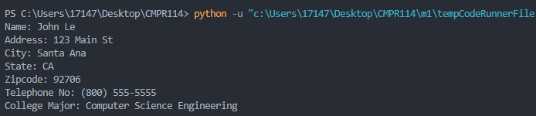

Code:

fullname = "John Le"

address = "123 Main St"

city = "Santa Ana"

state = "CA"

zipcode= "92706"

telephoneno = "(800) 555-5555"

major = "Computer Science Engineering"

print("Name: " + fullname +

"\nAddress: " + address +

"\nCity: " + city +

"\nState: " + state +

"\nZipcode: " + zipcode +

"\nTelephone No: " + telephoneno +

"\nCollege Major: " + major + "\n")

**Project #2**

Complete the Total Purchase program.

**#2 Print screen the output with the code below here.**

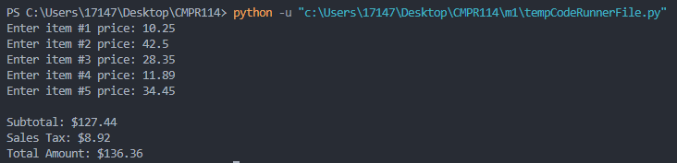

Code:

price1 = float(input("Enter item #1 price: "))

price2 = float(input("Enter item #2 price: "))

price3 = float(input("Enter item #3 price: "))

price4 = float(input("Enter item #4 price: "))

price5 = float(input("Enter item #5 price: "))

totalprice = price1 + price2 + price3 + price4 + price5

salestaxpct = .07

salestax = totalprice * salestaxpct

totalamount = totalprice + salestax

print("\nSubtotal: ${:,.2f}".format(totalprice))

print("Sales Tax: ${:,.2f}".format(salestax))

print("Total Amount: ${:,.2f}".format(totalamount))

**Project #3**

Complete the Sales Tax program.

**#3 Print screen the output with the code below here.**

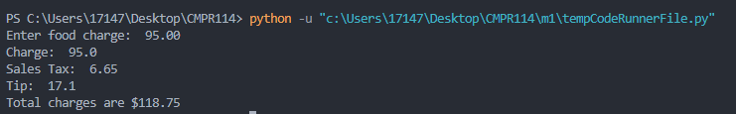

Code:

foodcharge = float(input("Enter food charge: "))

salestax = round(foodcharge * .07, 2)

tip = round(foodcharge * .18, 2)

totalcharge = foodcharge + salestax + tip

print("Charge: ", foodcharge)

print("Sales Tax: ", salestax)

print("Tip: ", tip)

print("Total charges are ${:,.2f}".format(totalcharge))

**Project #4**

Complete the program.

**#4 Print screen the output with the code below here.**

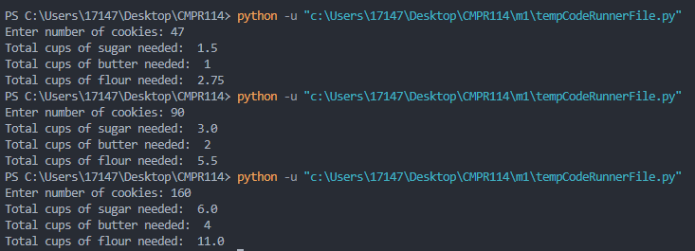

Code:

cookiecnt = int(input("Enter number of cookies: "))

if cookiecnt <= 48:

batchcnt = 1

else:

batchcnt = cookiecnt // 48

remainder = cookiecnt % 48

if remainder > 0:

batchcnt = batchcnt + 1

sugar = batchcnt * 1.5

butter = batchcnt

flour = batchcnt * 2.75

print("Total cups of sugar needed: ", sugar)

print("Total cups of butter needed: ", butter)

print("Total cups of flour needed: ", flour)

**Project #5**

**#5 Print screen the output with the code below here.**

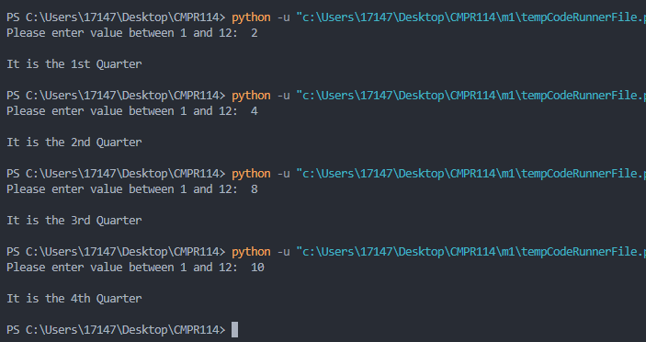

Code:

def calc_quarter(monthval):

if monthval >= 1 and monthval < 4:

quarter = "1st"

elif monthval >= 4 and monthval < 7:

quarter = "2nd"

elif monthval >= 7 and monthval < 10:

quarter = "3rd"

else:

quarter = "4th"

return quarter

def validate(monthval):

if monthval < 1 or monthval > 12:

return False

else:

return True

monthval = int(input("Please enter value between 1 and 12: "))

result = validate(monthval)

if result == True:

val = calc_quarter(monthval)

print("\nIt is the " + val + " Quarter\n")

**Project #6**

**#6 Print screen the output with the code below here.**

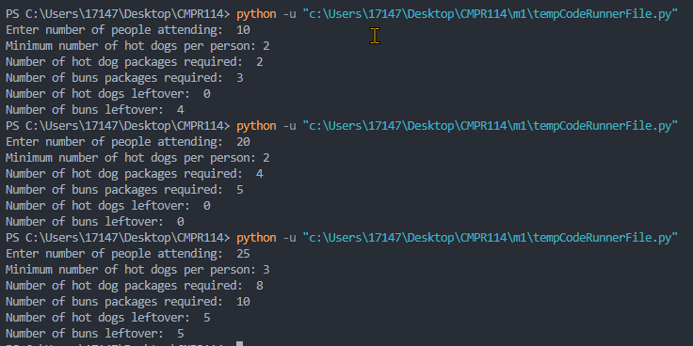

Code:

peoplecnt = int(input("Enter number of people attending: "))

hotdogcnt = int(input("Minimum number of hot dogs per person: "))

totalhotdogs = peoplecnt * hotdogcnt

#calculate number of hot dogs packages

hotdogspkg = totalhotdogs // 10

hotdogsrem = totalhotdogs % 10

if hotdogsrem > 0:

hotdogspkg = hotdogspkg + 1

hotdogsleftover = (hotdogspkg * 10) - totalhotdogs

else:

hotdogsleftover = 0

#calculate number of buns packages

bunspkg = totalhotdogs // 8

bunsrem = totalhotdogs % 8

if bunsrem > 0:

bunspkg = bunspkg + 1

bunsleftover = (bunspkg * 8) - totalhotdogs

else:

bunsleftover = 0

print("Number of hot dog packages required: ", hotdogspkg)

print("Number of buns packages required: ", bunspkg)

print("Number of hot dogs leftover: ", hotdogsleftover)

print("Number of buns leftover: ", bunsleftover)

**Project #7**

**#7 Print screen the output with the code below here.**

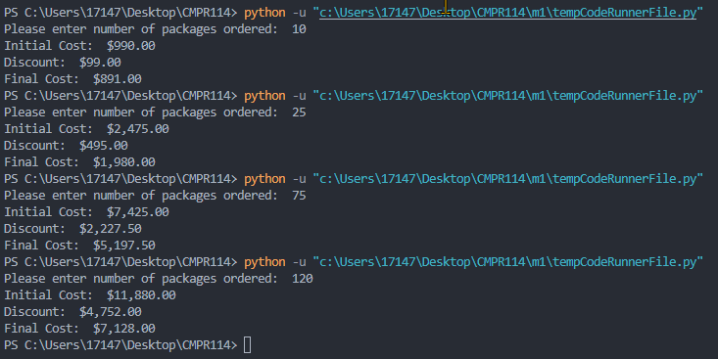

Code:

def calc_discount(quantity):

discount = 0

if quantity >= 10 and quantity < 20:

discount = .1

elif quantity >= 20 and quantity < 50:

discount = .2

elif quantity >= 50 and quantity < 100:

discount = .3

else:

discount = .4

return discount

cost = 99.0

quantity = int(input("Please enter number of packages ordered: "))

totalcost = quantity * cost

discountpct = calc_discount(quantity)

totaldiscount = totalcost * discountpct

finalprice = totalcost - totaldiscount

print("Initial Cost: ${:,.2f}".format(totalcost))

print("Discount: ${:,.2f}".format(totaldiscount))

print("Final Cost: ${:,.2f}".format(finalprice))

**Submit this document to Module 1 homework.**